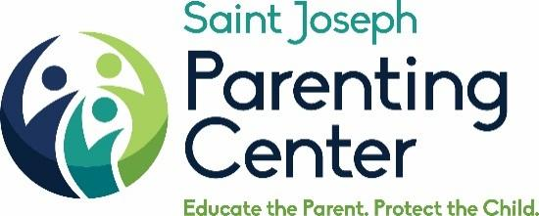

SPONSORSHIP OPPORTUNITIES
April 22, 2020 Annual Benefit Breakfast

SPONSORSHIP BENEFITS | Parenting Champion Sponsor | SJPC Support Groups Champion Sponsor | SJPC Cares (Childcare) Champion Sponsor | Friends of SJPC Sponsor | Individual Table
 | $20,000 | $10,000 | $5,000 | $2,500 | $1,000
Event Tickets | 20 | 10 | 10 | 10 | 10
Premium Seating | X | X | X
Recognition from Podium | X
Recognition on Invitation | X | X
Recognition on Program,  Event Signage and SJPC website | X | X | X | X
Corporate Name on Table | X | X | X | X
Meet and Greet with Speaker | X | X

For More Information please contact Barbara Russell @ brussell@sjpcenter.org

